

Data Lake and Data Warehouse
Year 2 (2025/26), Semester 4

SCHOOL OF INFOCOMM TECHNOLOGY
Diploma in Data Science

ASSIGNMENT
Part B
Individual

Module Group: | P01 or P02
Student ID: | S10267332J
Student Full Name: | SIMON SAW YONG PING

Contents
SCHOOL OF INFOCOMM TECHNOLOGY 1
Part B Question 1 3
Part B Question 2 10
Screenshots 12
Report 14
Pipeline 14
Challenges and Resolutions 14
Performance demonstration (Partition pruning) 15
Conclusion 15
Part B Question 3 Reflection 16

Part B Question 1
Part B comprises Question 1, 2 and 3 (50 Marks)

Question 1 (15 Marks) – Individual

Pre-Assignment Requirement
You are required to complete the practical for “Week 13 - Working External Tables in Data Lake”.

You have learnt about the benefits of Partitioning External Tables, which can significantly improve query performance. By partitioning external data into separate slices or parts, query response times are faster because only a small portion of the data is processed instead of scanning the entire dataset.

In this assignment, you are tasked with partitioning the files by the following criteria and providing evidence of the performance improvement with a screenshot of the Query Profile:
- Year
- Quarter
- Month

(Extra Bonus 5 marks): Explore and implement additional granular partitioning schemes and demonstrate their impact on query performance.

Step 1: Create a new worksheet “2”

Step 2: Set Context and Suspend Warehouse

When working your scripts in Snowsight SQL Editor Pane, do remember to set context and suspend warehouse if not working on Snowflake.

Set Context
USE ROLE training_role;
ALTER SESSION SET QUERY_TAG= '(login)- Assignment: Working with External Table in Data Lake';
USE WAREHOUSE [login]_WH;
ALTER WAREHOUSE [login]_WH SET WAREHOUSE_SIZE = 'XSMALL';
USE DATABASE [login]_DB;
USE SCHEMA RAW;
Suspend Warehouse if not working on Snowflake
ALTER SESSION UNSET QUERY_TAG;
ALTER WAREHOUSE [login]_WH SET WAREHOUSE_SIZE = 'XSMALL';
ALTER WAREHOUSE [login]_WH SUSPEND;

If you are not working on Snowflake, remember to:
- Logout of Snowflake and
- Close the Snowflake browser
Your credit usage will be monitored by the tutor and marks will be deducted for any unnecessary usage.

Step 3: Create New Store Procedure (SP) by modifying the existing SP in your practical

- Create a new Procedure Name: “ASG_UNLOAD_ONTIME_REPORTING_CSV” and make necessary changes based on the requirements.
- Make sure when calling your SP, the first parameter is as follows:
  - FOLDER change to ‘ASG’, see screenshot below as an example.

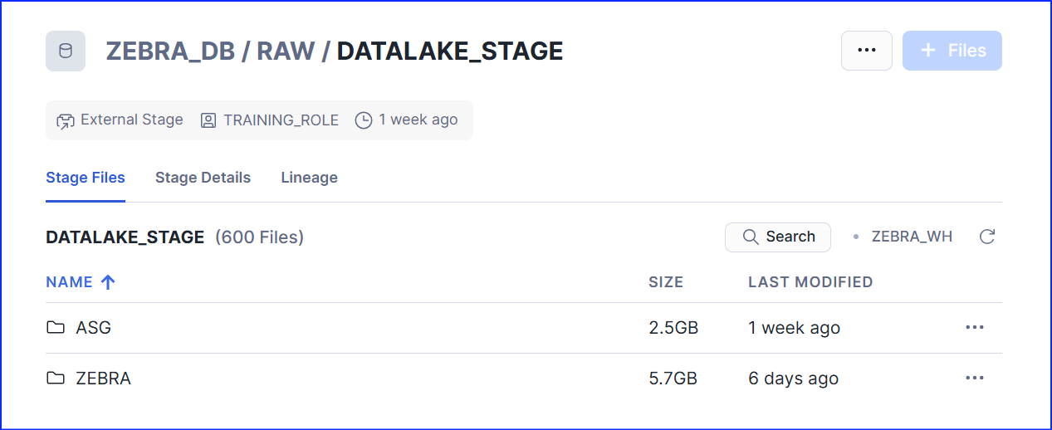

Step 4: Capture the screenshot of your New SP under [login]_DB.RAW schema

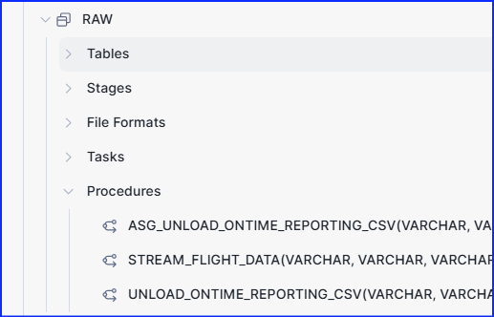

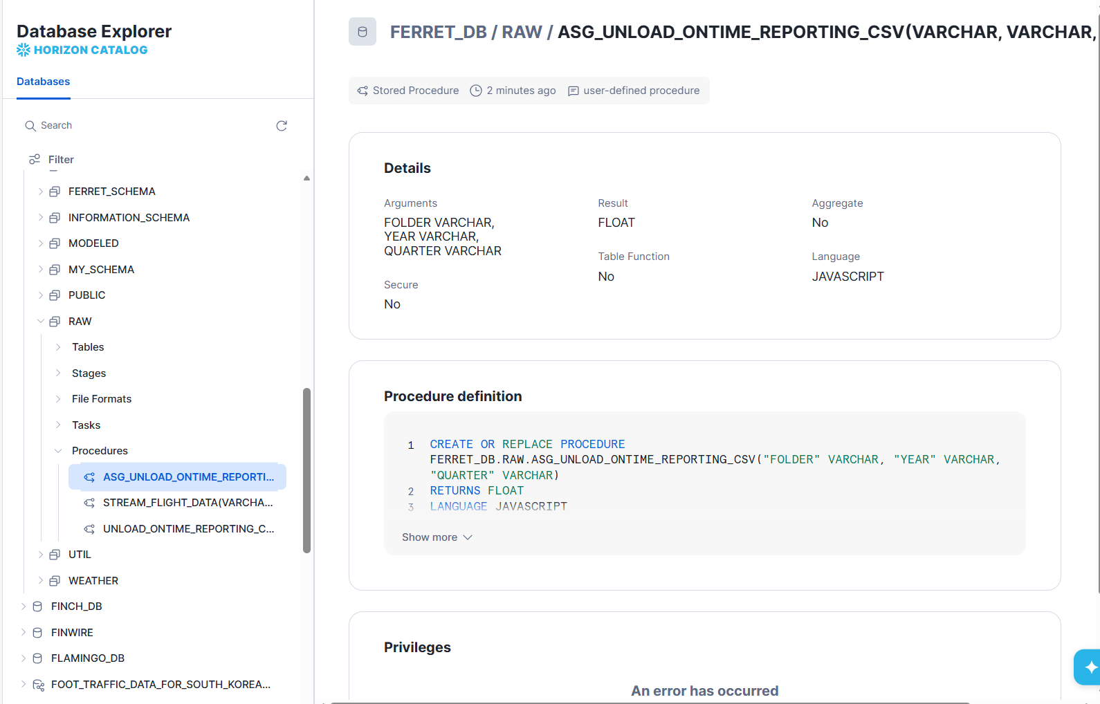

Step 5: Paste your New SP scripts below:

CREATE OR REPLACE PROCEDURE "ASG_UNLOAD_ONTIME_REPORTING_CSV"("FOLDER" VARCHAR, "YEAR" VARCHAR, "QUARTER" VARCHAR) RETURNS FLOAT LANGUAGE JAVASCRIPT STRICT EXECUTE AS OWNER AS ' var counter = 0; var unload_qry = snowflake.execute({ sqlText: "copy into @raw.datalake_stage/" + FOLDER + "/" + YEAR + "Q" + QUARTER + "_OTP from (" + " select * from raw.ONTIME_REPORTING WHERE YEAR = ''" + YEAR + "'' AND QUARTER = ''" + QUARTER + "''" + ") OVERWRITE=TRUE file_format = (type = ''CSV'' COMPRESSION = NONE FIELD_DELIMITER = '','' " + " skip_header = 1 NULL_IF = () FIELD_OPTIONALLY_ENCLOSED_BY=''\\"'');" }); return counter; ';

Step 6: Refer to Appendix to check the Quarters assigned to you. Load all months under the assigned quarters from 2018 to 2021 to the stage.
For example, if Q1 is assigned to you, you will need to load months M1, M2 and M3 (i.e. January to March) for the years 2018 to 2021.

Paste all the SP calls below to load the new files to the stage.
CALL RAW.ASG_UNLOAD_ONTIME_REPORTING_CSV('FERRET_ASG', '2018', '1');
CALL RAW.ASG_UNLOAD_ONTIME_REPORTING_CSV('FERRET_ASG', '2019', '1');
CALL RAW.ASG_UNLOAD_ONTIME_REPORTING_CSV('FERRET_ASG', '2020', '1');
CALL RAW.ASG_UNLOAD_ONTIME_REPORTING_CSV('FERRET_ASG', '2021', '1');

Step 7: Paste your scripts below for creating External Table with Partition function.
CREATE OR REPLACE EXTERNAL TABLE RAW.EXTERNAL_ONTIME_REPORTING_FERRET_ASG_PART (
year INT AS (SUBSTR(SPLIT_PART(METADATA$FILENAME, '/', -1), 1, 4)::INT),
quarter STRING AS (CONCAT('Q', SUBSTR(SPLIT_PART(METADATA$FILENAME, '/', -1), 6, 1))),

month INT AS (TRY_TO_NUMBER(value:c3::string)),
day_of_month INT AS (TRY_TO_NUMBER(value:c4::string)),
day_of_week INT AS (TRY_TO_NUMBER(value:c5::string)),
fl_date DATE AS (TRY_TO_DATE(value:c6::string)),
op_carrier STRING AS (value:c9::string),
origin STRING AS (value:c15::string),
dest STRING AS (value:c24::string),
arr_delay INT AS (TRY_TO_NUMBER(NULLIF(value:c43::string, '\\N'))),
cancelled INT AS (TRY_TO_NUMBER(NULLIF(value:c48::string, '\\N')))
)
PARTITION BY (year, quarter)
LOCATION = @RAW.DATALAKE_STAGE/FERRET_ASG
FILE_FORMAT = (FORMAT_NAME = 'RAW.ONTIME_REPORTING_CSV');

Step 8: Capture screenshots of the query results both with and without the Partitioning function applied. Then, compare the performance or results between the two scenarios, highlighting any differences.
Without Partition  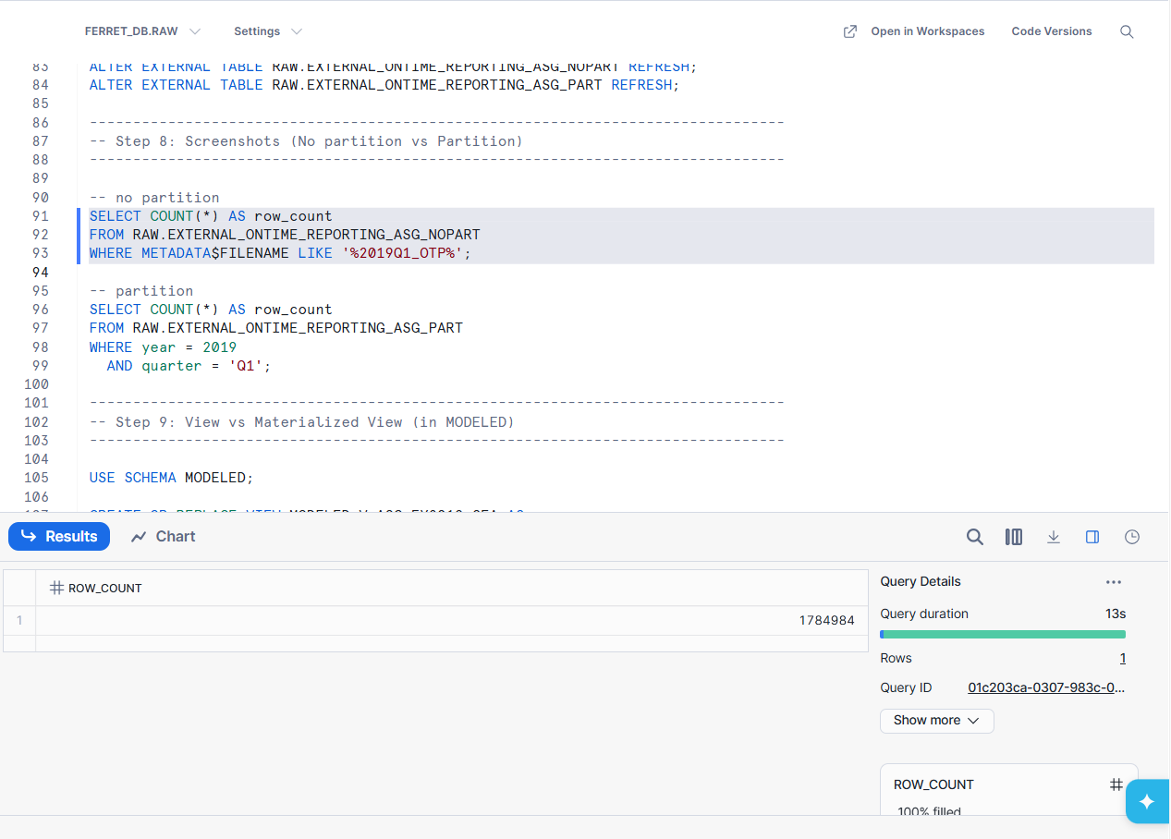  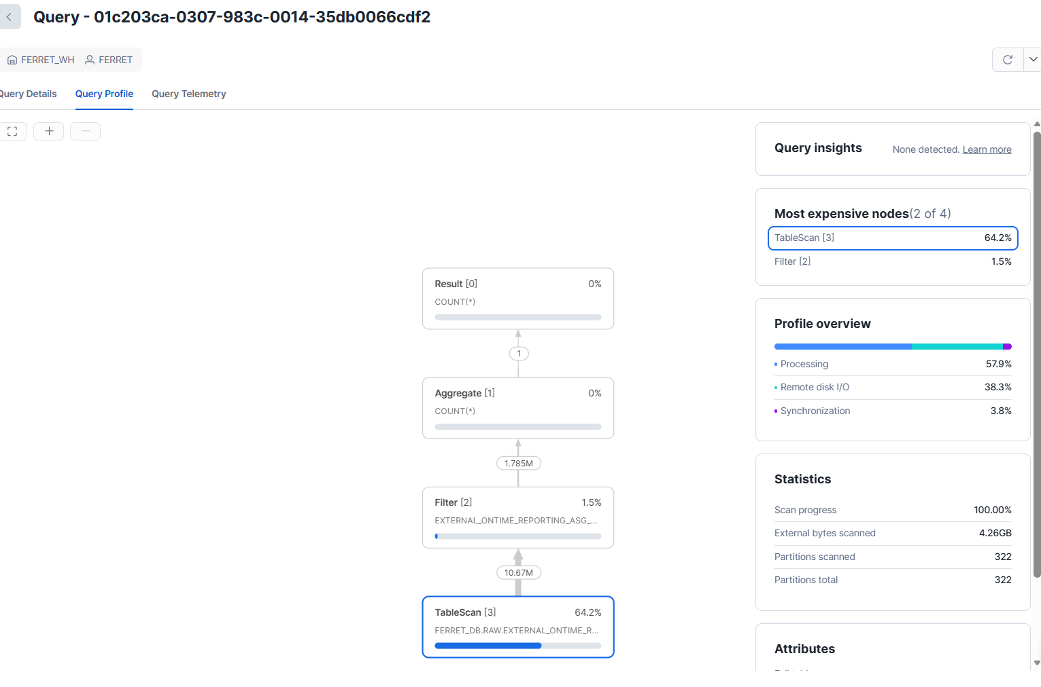  It took longer to run this query compared to the one with partitioning. Snowflake scans more external files because the filter is not applied via partition pruning. Query Profile usually shows higher bytes scanned.(4.2GB)  Same number of rows | With Partition  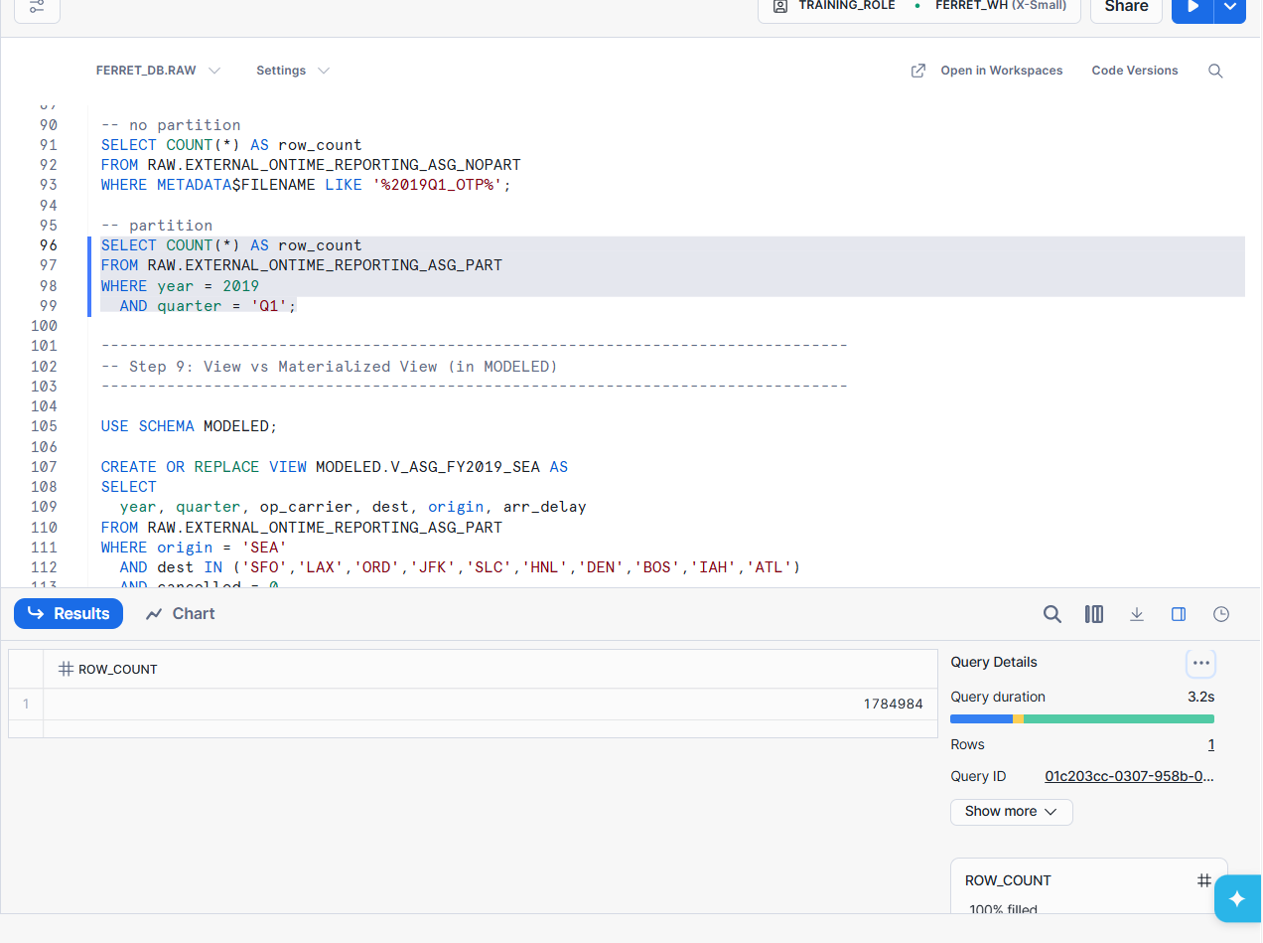  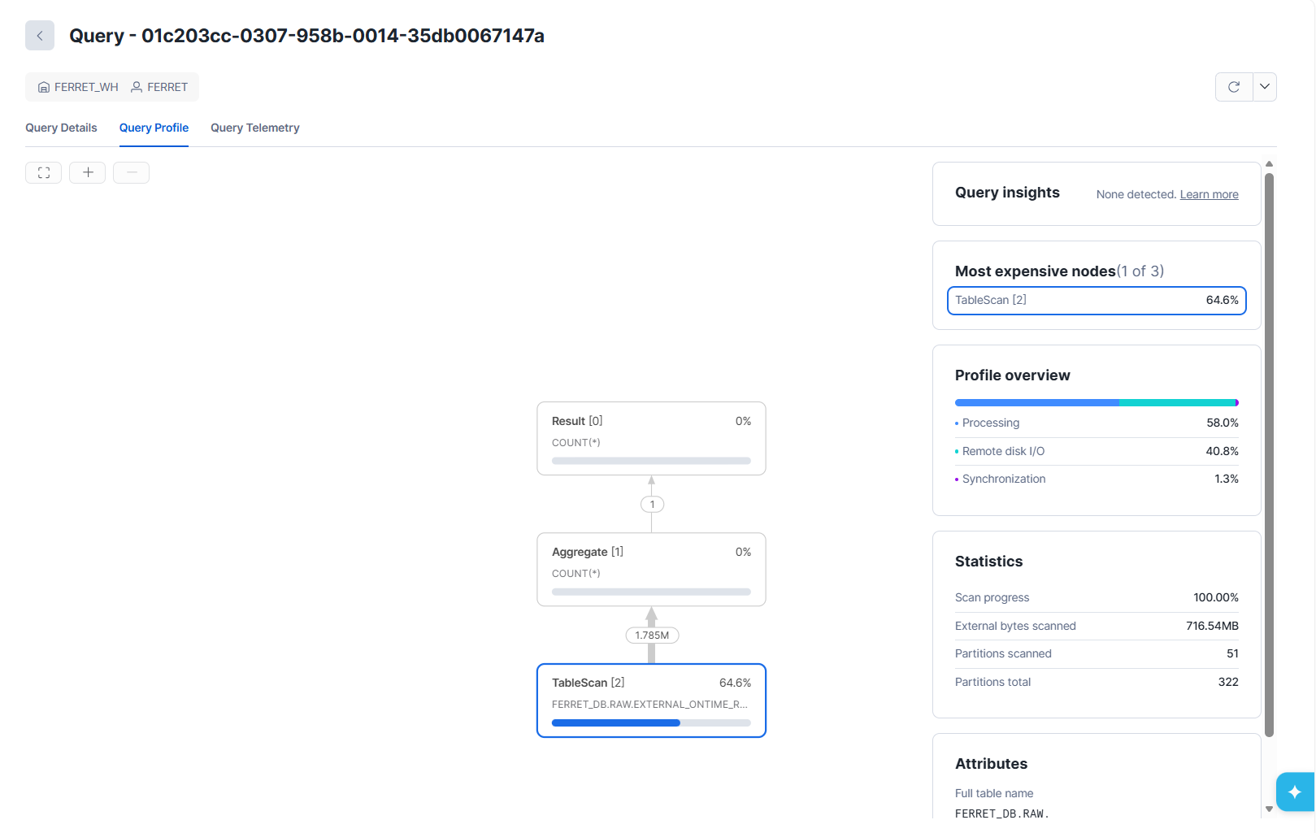  It took shorter to run this query compared to the one without partitioning. Snowflake performs partition pruning using year and quarter, so fewer partitions/files are scanned, reducing bytes scanned.(716mb)  Same number of rows

Step 9: Capture screenshots of the query results both View and Materialized View function applied. Then, compare the performance or results between the two scenarios, highlighting any differences.
View  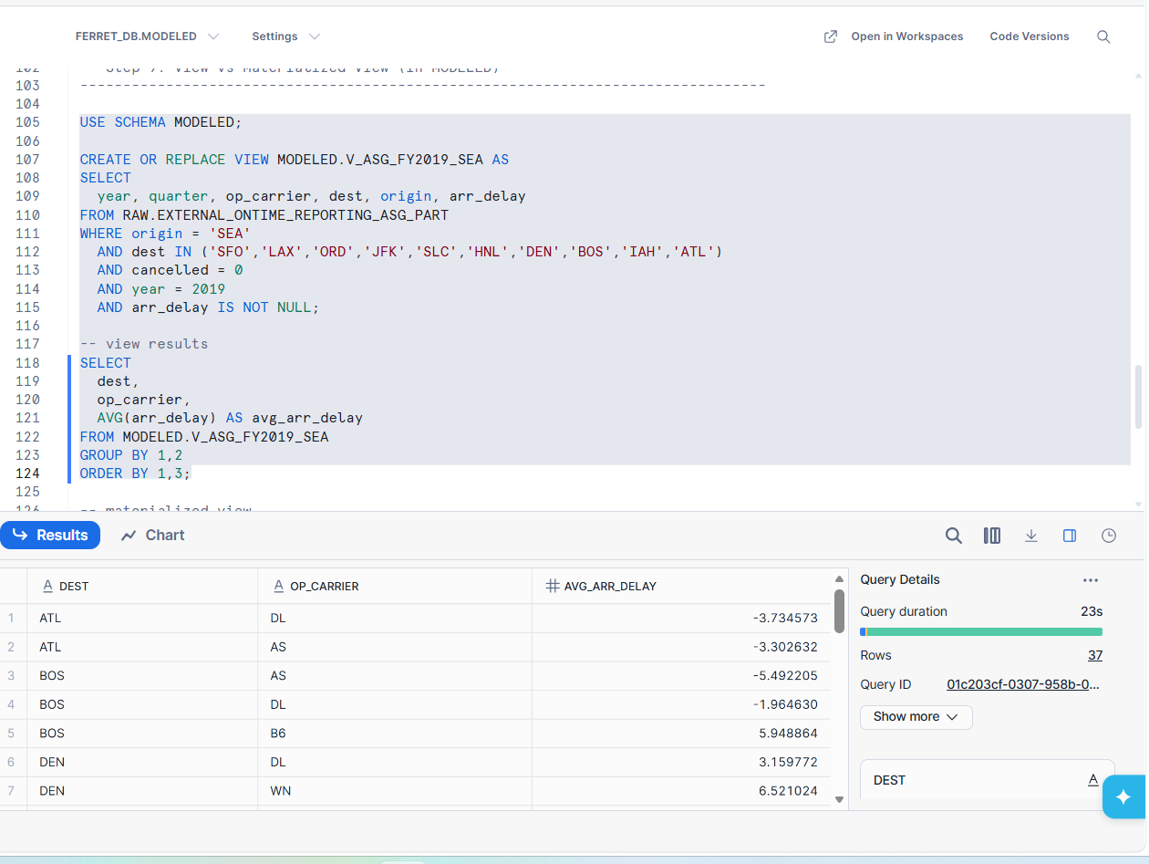  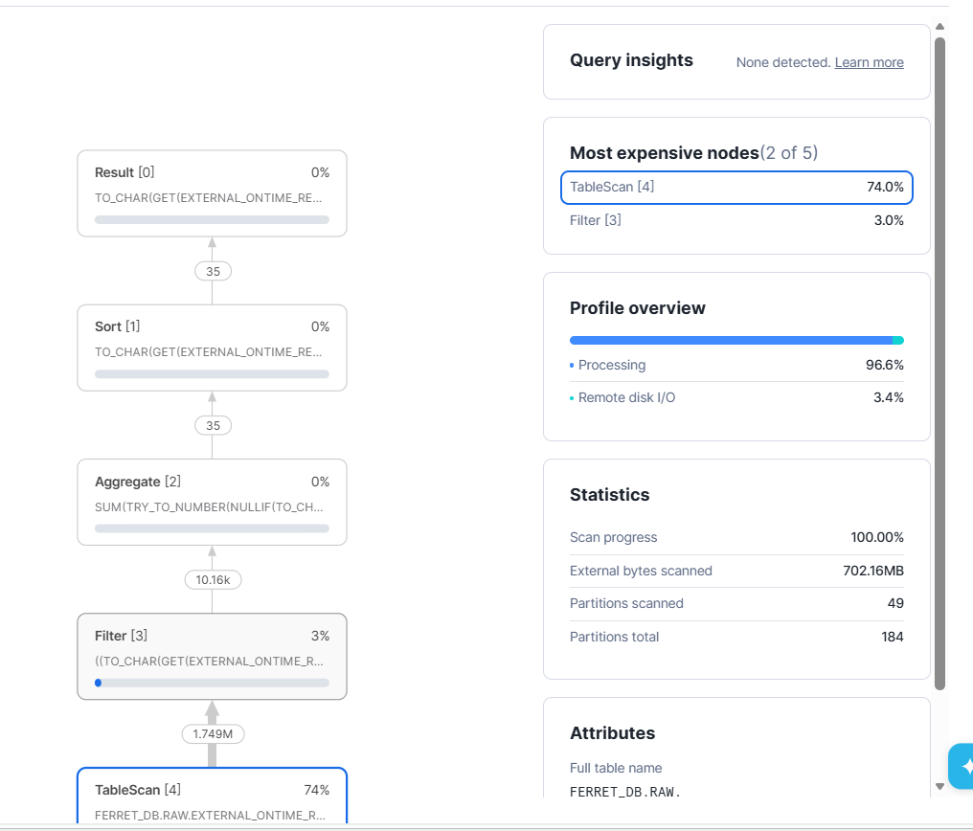  A standard view executes its logic at query time, meaning each execution scans the underlying external table and performs filtering and aggregation dynamically. Even with partition pruning applied, the Query Profile shows that a significant portion of the cost is attributed to table scans and aggregation operations, which must be recomputed every time the view is queried. This makes standard views flexible and always up to date, but less efficient for repeated analytical queries on large datasets. | Materialized View  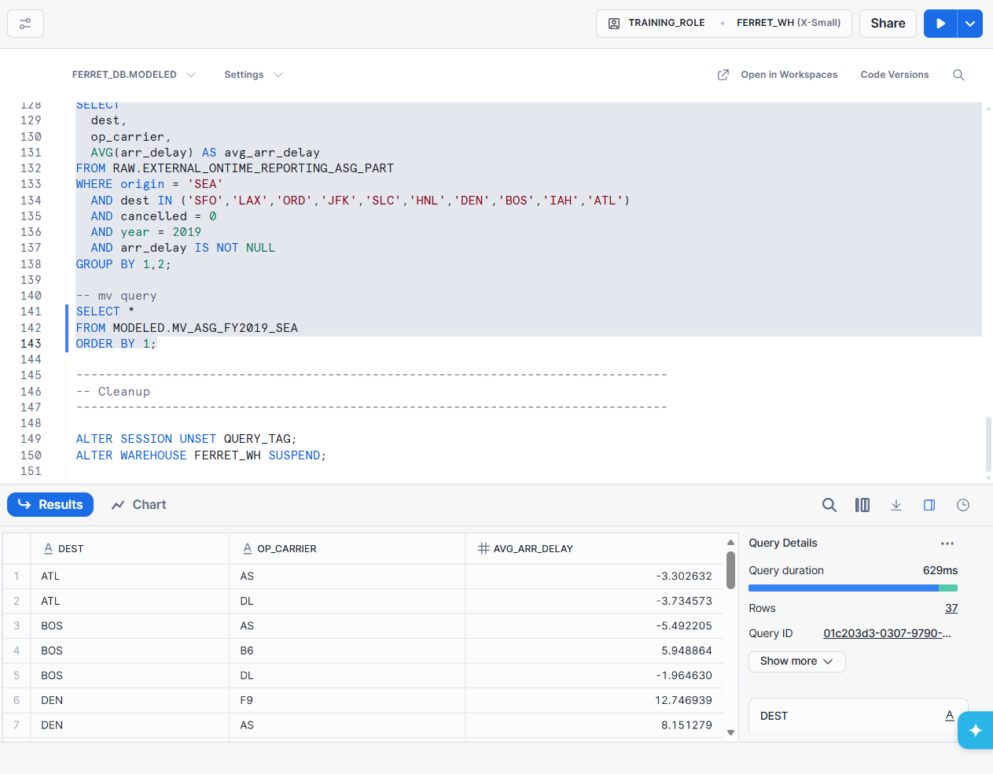  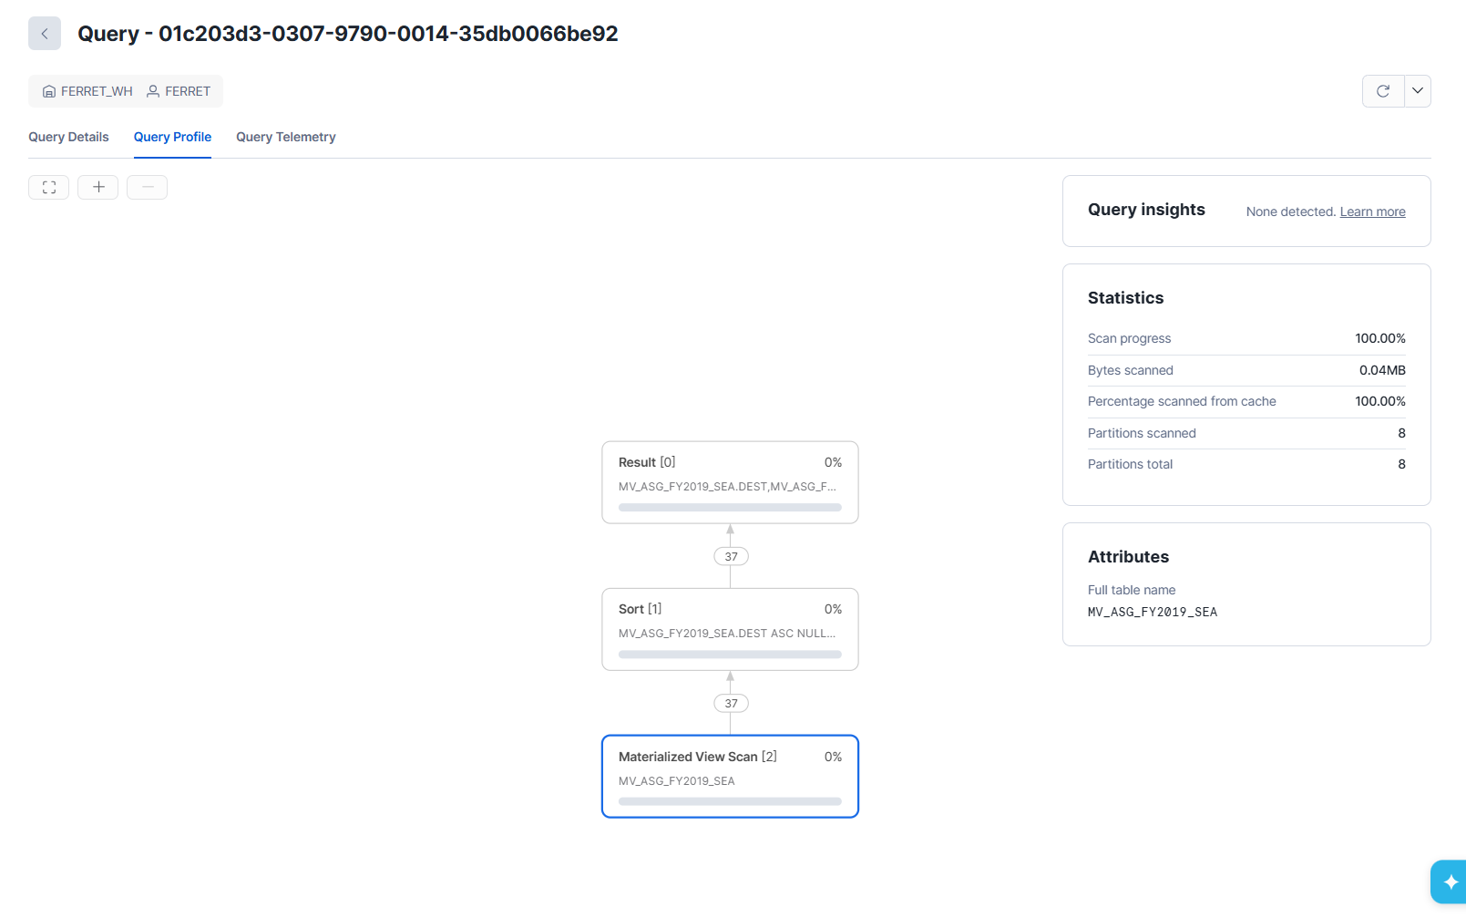  A materialized view stores the precomputed results of the query, allowing Snowflake to read directly from the materialized storage instead of scanning and aggregating the raw external table. As a result, the Query Profile shows fewer execution nodes, no expensive table scans, and lower overall query cost. This leads to faster and more consistent performance, making materialized views more suitable for recurring reporting and analysis workloads, at the trade-off of slightly reduced data freshness.

Part B Question 2
Question 2 (25 Marks) – Individual

Automating Transformations with Unstructured Data Using UDFs, Streams, and Tasks

Pre-Assignment Requirement - Complete Before Starting Question 2 Below

Before beginning Question 2, please refer to the Week 14 practical ("Transformations with Unstructured Data") for guidance on handling unstructured data. In this practical, you will learn how to set up directory tables, creating streams for detecting new files, implement User-Defined Functions (UDFs) for parsing PDFs, and automate pipelines using tasks. These concepts will be crucial for tasks such as refreshing metadata, processing PDFs, and chaining tasks in a Directed Acyclic Graph (DAG).

In this part of the assignment, you will extend the curated dataset in Part A by automating the processing of unstructured data (e.g., PDFs from Part A) using a User-Defined Function (UDF), streams for change detection, and tasks for scheduled execution. This will simulate a continuous data pipeline in a data lake/warehouse environment, where new unstructured files (e.g., PDFs containing reports linked by IDs) are automatically parsed, transformed, and integrated with structured data (e.g., from flattened JSON in Part A and partitioned external tables in Part B Question 1).

You will use the unstructured PDFs from Part A (or generate new ones if needed, adhering to limits) and build an automated pipeline to extract text/content from them, store parsed results in a table, and create a view combining this with your curated dataset. You must use a Python UDF (sample provided below). You must integrate partitioning from Part B's external tables as a data source and demonstrate performance improvements via Query Profile screenshots.

Objectives:
The scenario in this part aligns with the following key objectives, building on Parts A and B:

1. Create and Use UDFs for Unstructured Data:
• Develop a UDF (Python) to parse/extract text from PDFs, simulating real-world unstructured processing.

2. Detect Changes with Streams on Directory Tables:
• Use streams to monitor new/updated unstructured files in stages.

3. Automate Pipelines with Tasks:
• Chain tasks in a DAG (Directed Acyclic Graph) to process raw unstructured data into curated tables/views.

4. Combine Structured and Unstructured Data:
• Create views joining parsed unstructured data with structured data from Part A and Part B's partitioned external tables.

5. Monitor and Handle Pipeline Execution:
• Use Snowflake functions to check task history, errors, and graph status.

6. Adhere to Efficiency Best Practices:
• Ensure automation minimizes manual intervention while handling file size/count limits from Part A, and demonstrate performance improvements from integrating Part B's partitioned external tables via Query Profile screenshots.

Requirements and Deliverables in Snowflake:

Step 1: Create a new worksheet “Your Full Name DLW ASG – Part B Q2”

Step 2: Set Context and Suspend Warehouse

When working your scripts in Snowsight SQL Editor Pane, do remember to set context and suspend warehouse if not working on Snowflake.

Set Context
USE ROLE training_role;
ALTER SESSION SET QUERY_TAG= '(login)- Assignment: Automating Transformations with Unstructured Data Using UDFs, Streams, and Tasks';
USE WAREHOUSE [login]_WH;
AUTO_SUSPEND = 60
INITIALLY_SUSPENDED = true;
ALTER WAREHOUSE [login]_WH SET WAREHOUSE_SIZE = medium;
USE DATABASE [login]_DB;
Suspend Warehouse if not working on Snowflake
ALTER SESSION UNSET QUERY_TAG;
ALTER WAREHOUSE [login]_WH SET WAREHOUSE_SIZE = medium;
ALTER WAREHOUSE [login]_WH SUSPEND;

If you are not working on Snowflake, remember to:
- Logout of Snowflake and
- Close the Snowflake browser
Your credit usage will be monitored by the tutor and marks will be deducted for any unnecessary usage.

Screenshots
UDF outputs:
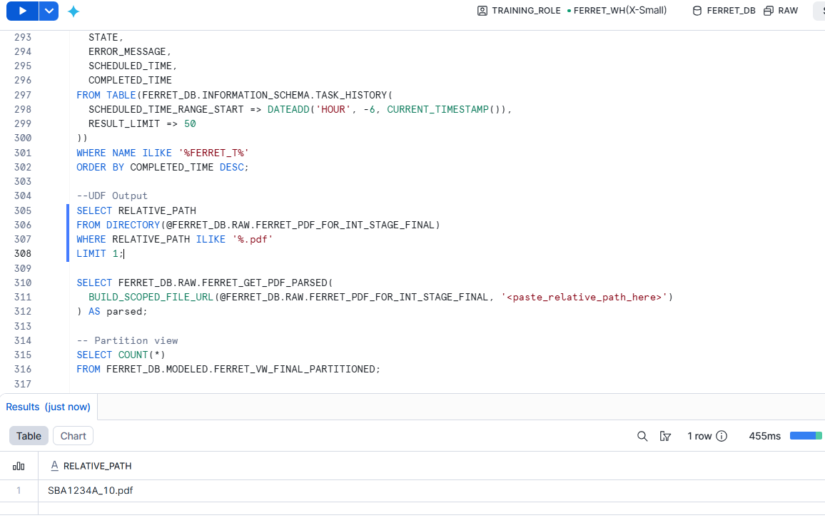

Stream data:
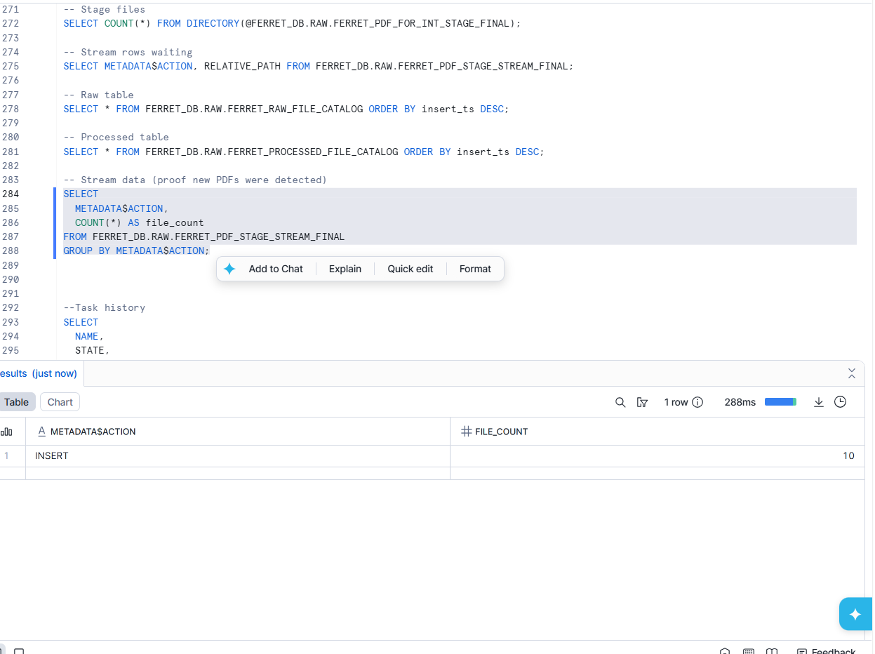

Task History:
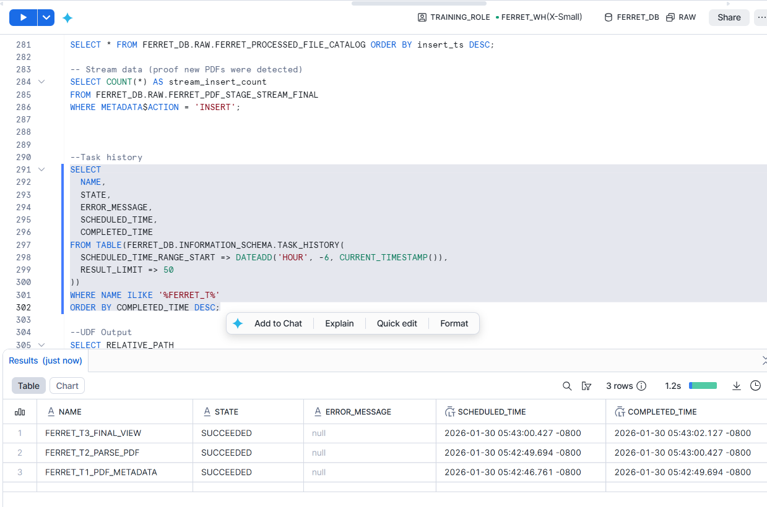

Partitioned Query Profile:
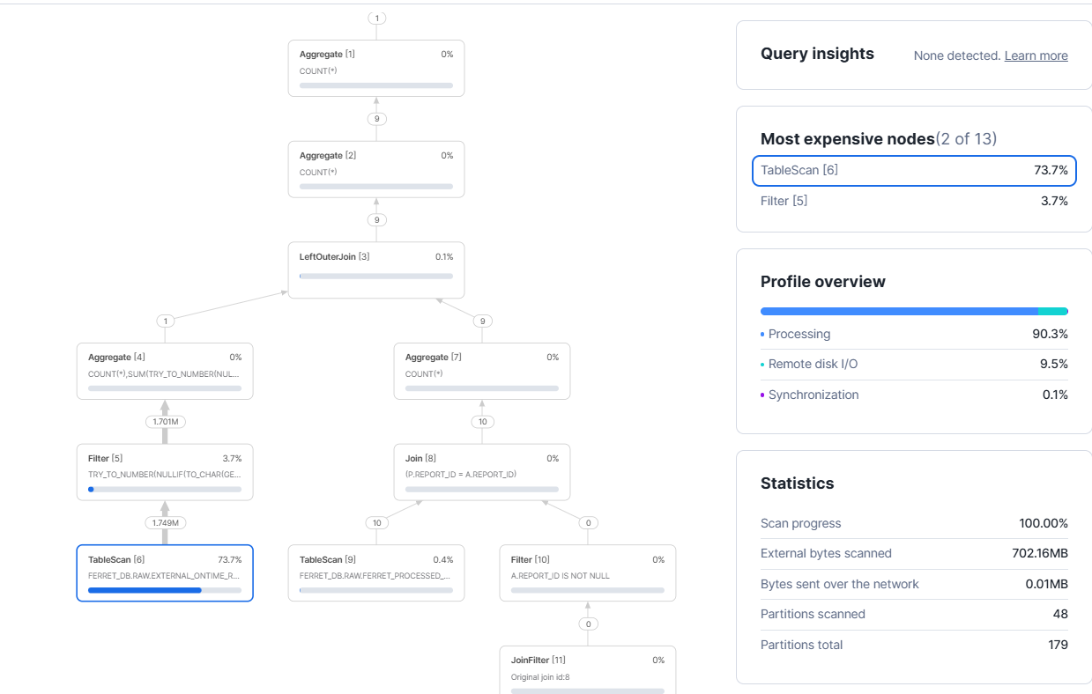
Non Partitioned Query Profile :
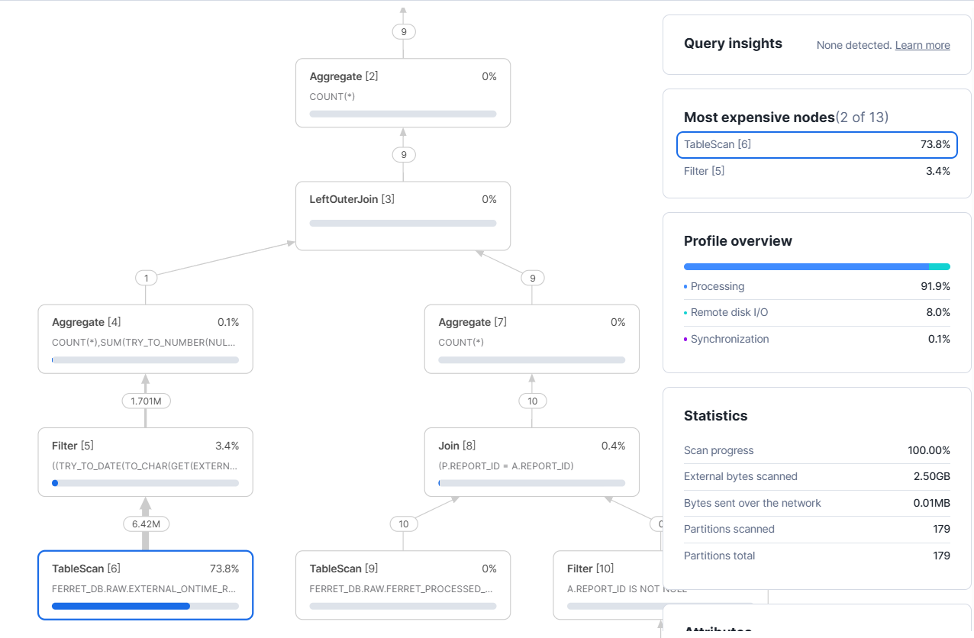

Report

Pipeline
- PDF Stage + Directory Table
PDFs are stored in an internal Snowflake stage with directory tables enabled to track file metadata.

- Stream on Stage
A stream on the stage directory captures file INSERT events when new PDFs are added and the stage is refreshed.

- T1 – Raw Metadata Load
T1 checks the stage stream and writes file metadata (file name, size, modified timestamp) and a scoped file URL into a raw catalog table.

- T2 – PDF Parsing (Python UDF)
T2 reads new rows from a stream on the raw catalog table and calls a Python UDF to extract metadata and main body text. Output is stored in a processed table called PROCESSED_FILE_CATALOG.

- T3 – Final Views (Partitioned vs Non-partitioned)
T3 creates two views:
- Partitioned view: uses YEAR + QUARTER predicates on the Part B external table for partition pruning.
- Non-partitioned view: filters the same time period using date logic (no explicit partition predicates), leading to less efficient scanning.
Both views join processed PDFs with Part A curated records by REPORT_ID, and attach Part B aggregated metrics for analysis.

Challenges and Resolutions
Challenge:
Once a stream is read by a downstream operation, its change records are marked as consumed and are no longer visible. Therefore, relying on the stage directory stream directly for multiple tasks risked missing records or breaking the task dependency chain which will break the code.
Resolution:
To resolve this, Task T1 was designed as the single consumer of the stage stream, responsible only for inserting raw file metadata into a raw catalog table. A separate stream on the raw catalog table was then created and consumed by Task T2. This ensures that each task in the DAG has a clearly defined and independent input stream, allowing reliable chaining (T1 → T2 → T3) without data loss or race conditions.

3.2 Exploding joins and inefficient join conditions
Challenge:
The initial implementation joined the processed PDF records directly to the Part B external flight table, which contains millions of rows. Because there was no one-to-one join key between PDFs and individual flight records, this resulted in an exploding join, where each PDF row was matched with a very large number of flight rows. This led to excessive row counts, high compute cost, and poor query performance, as highlighted by Snowflake Query Insights.
Resolution:
The issue was resolved by pre-aggregating the Part B external table using a Common Table Expression (CTE) before joining. Key metrics such as average arrival delay and flight counts were computed at the required granularity, producing a very small result set. The final views then join this aggregated output to the processed PDF data, eliminating the row explosion while still preserving the analytical value of the Part B data.

Performance demonstration (Partition pruning)
Two queries were executed and compared using Query Profile:
- Partitioned view (YEAR + QUARTER filter): Fewer partitions scanned and lower bytes scanned due to partition pruning.
- Non-partitioned view : More partitions scanned and higher bytes scanned.
Query Profile screenshots show improved efficiency when partition columns are used in filters.

Conclusion
This pipeline demonstrates a robust and scalable approach to integrating unstructured PDF data with structured and partitioned datasets in Snowflake. By leveraging directory tables, streams, Python UDFs, and a task-based DAG, the solution enables reliable and automated end-to-end processing with clear separation of responsibilities across ingestion, parsing, and integration stages. Secure access via scoped URLs ensures controlled file handling, while incremental processing, pre-aggregation, and partition pruning significantly reduce compute cost and improve query performance. Overall, the design balances automation, security, and efficiency, making it well-suited for production-scale analytical workloads involving unstructured data.

Part B Question 3 Reflection
I really enjoyed this module as this module has been a comprehensive and practical introduction to modern data engineering using Snowflake. Through a combination of guided practicals and the final assignment, I gained hands-on experience in building end-to-end data pipelines, working with multiple data types, and optimising query performance in a cloud data platform. Compared to my initial understanding of data engineering, this module allowed me appreciate of how scalable, automated, and amazing Snowflake as a workflow is designed.

One of the most helpful Snowflake features was the “ALTER … RESUME/SUSPENDED”.
I found this to be really helpful during both my practicals and assignments as it assisted me greatly in the completion of the assignment. Features such as stages, directory tables, streams, tasks, and Python UDFs were especially helpful during the practicals. Directory tables and streams enabled event-driven processing of new data, allowing me to design incremental pipelines rather than relying on full reloads. These features improved my workflow by reducing manual intervention, enforcing execution order, and ensuring data consistency across different processing stages.

Semi-structured data, such as JSON, was handled using Snowflake’s VARIANT type and built-in functions for extraction and flattening. For Unstructured data, I had to create and use internal stages, scoped URLs, and Python UDFs with libraries like PyPDF2 allowed me to extract meaningful text and metadata from PDFs and integrate them with structured datasets. This showed Snowflake is a diverse platform when it comes to data types.

Functions and techniques such as partition pruning, pre-aggregation using CTEs, and materialized views played a critical role in improving query efficiency. By filtering on partition columns (such as YEAR and QUARTER) when querying external tables, I was able to significantly reduce the number of partitions scanned, as shown in Query Profile comparisons.

And as for teamwork, I found my group to be really collaborative and cooperative. We swiftly finished all tasks and quickly finished Part A. We also split tasks fairly so that everyone gets a fair share and no one has to independently carry the group. This collaborative process highlighted how data engineering is rarely a solo effort and often benefits from peer reviews and shared problem-solving.

Through this module, I learned that data engineering is not just about writing SQL, but about designing reliable, scalable, and efficient data systems. My understanding of Snowflake evolved from seeing it as a simple cloud data warehouse to appreciating it as a full data platform capable of handling ingestion, transformation, orchestration, and optimisation.

Reflecting on my Week 1 self-introduction video, I initially focused on learning tools and basic data handling skills. After completing this module, my perspective has shifted toward system design, automation, and performance awareness. The hands-on experience has made the concepts far more concrete than theoretical learning alone.

One area related to AI that I would like to explore further is machine learning model integration with data pipelines. To continue developing my skills, I plan to work on personal projects using Snowflake and explore additional resources such as online courses, documentation, and industry case studies. This module has provided a strong foundation and motivated me to continue building expertise in both data engineering and AI-driven analytics.

